Sample request and response

- Shorten URL when provided with a long URL
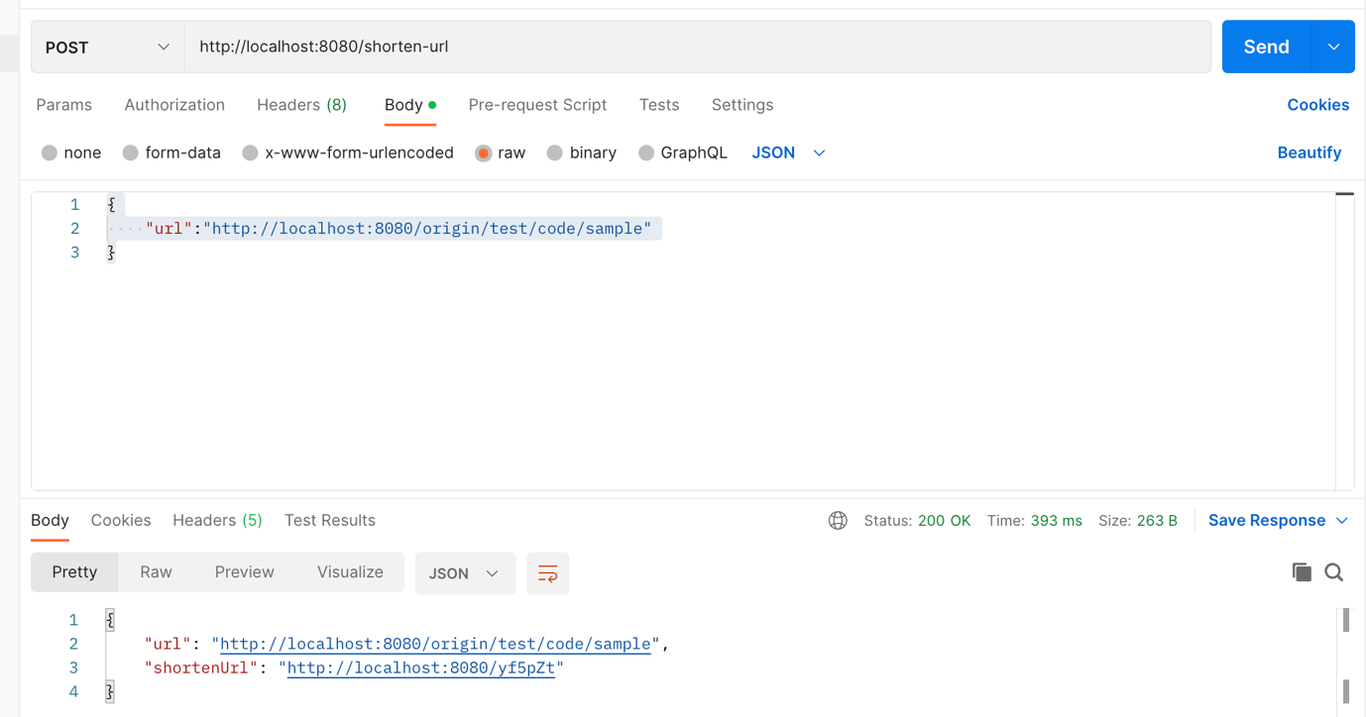

- Redirect to Original URL when a short URL is requested and get back long original url

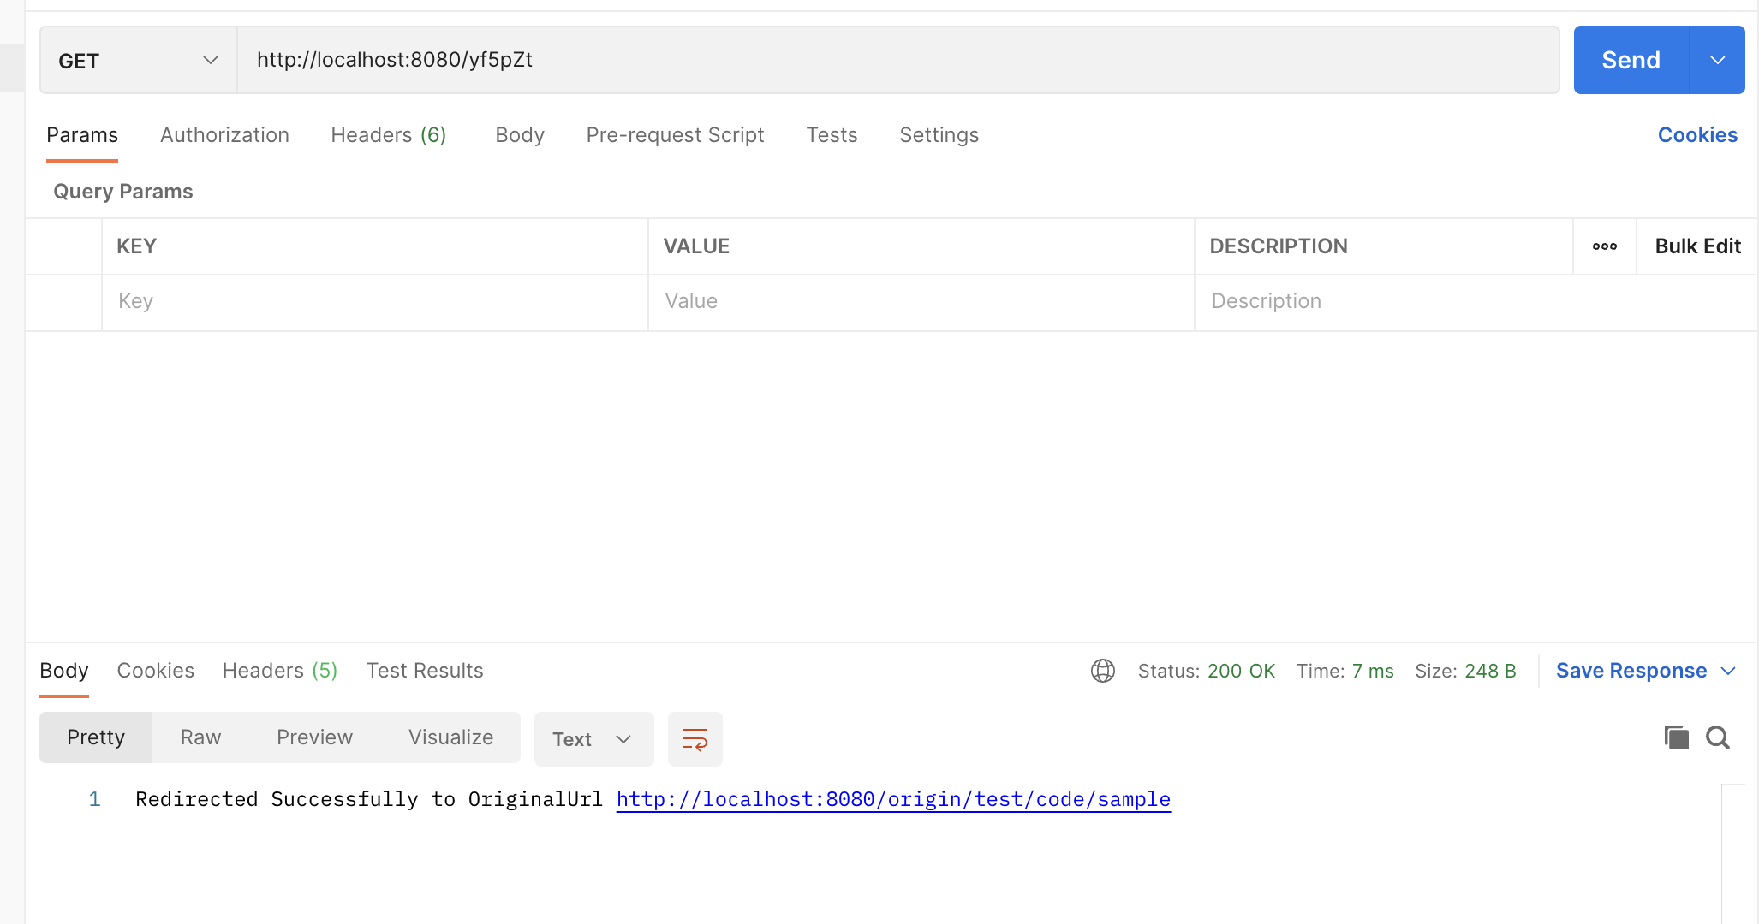

- Sample response for error handling and invalid url scenarios.
